**GROUP 5.9**

**Name - Rushikesh Nalla**

**ID - 201401106**

**Name - Omkar Damle**

**ID - 201401114**

**Interaction modeling**

**CENTRALISED SCHOLARSHIP MANAGEMENT SYSTEM**

**Use case scenario: Apply for scholarship**

**Sequence Diagram**

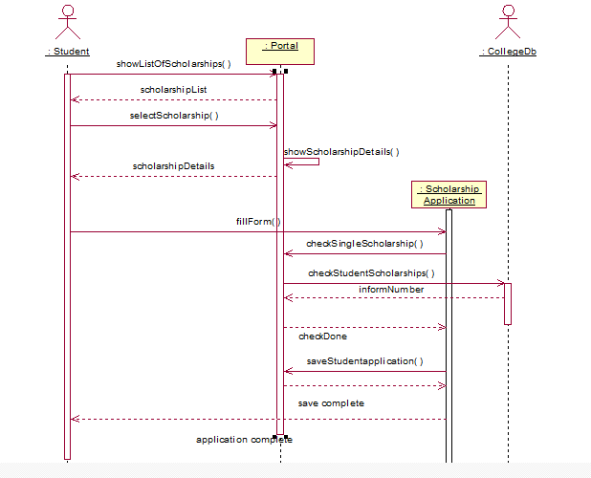

**Collaboration Diagram**

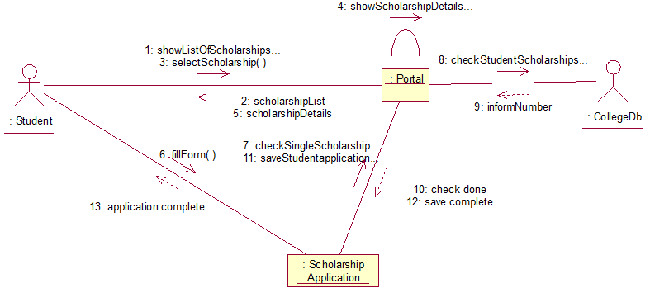

**Use case scenario: Introduce/Edit scholarship**

**Sequence Diagram**

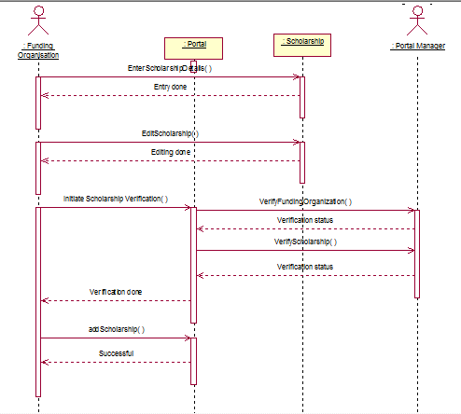

**Collaboration Diagram**

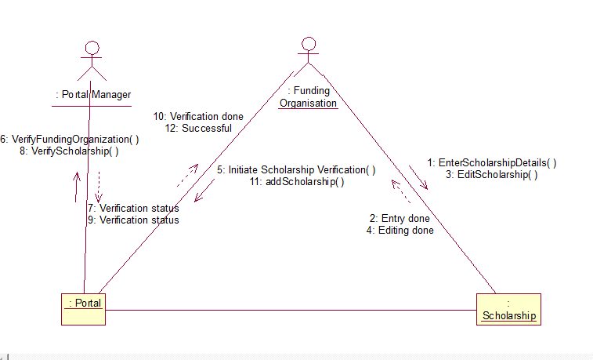

**Use case scenario: Pay scholarship**

**Sequence Diagram**

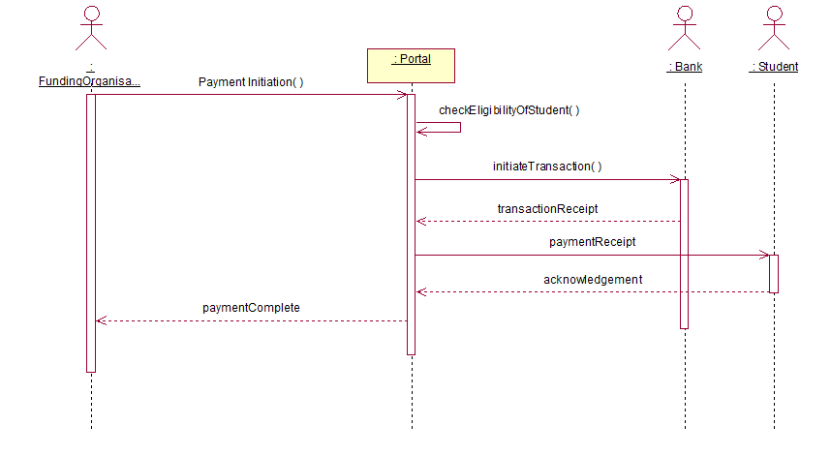

**Collaboration Diagram**

